# “IOT based Smart Home Automation and Security System with Smart lock using Mobile App”

A Project Report (Project Work I) Submitted in partial fulfillment of requirement of the

Degree of

**BACHELOR OF TECHNOLOGY in ELECTRONICS AND COMMUNICATION**

# BY

### Saransh Maheshwari (EN19EL301120)

### Tushar Trivedi (EN19EL301142)

### Vaibhav Mani Diwankar (EN19EL301144)

Under the Guidance of

### Mr. Manish Mahajan

**Department of Electronics Engineering Faculty of Engineering**

### MEDI-CAPS UNIVERSITY, INDORE- 453331

**AUG-DEC 2022**

### Report Approval

The project work **“IOT based Smart Home Automation and Security System with Smart lock using Mobile App”** is hereby approved as a creditable study of an engineering/computer application subject carried out and presented in a manner satisfactory to warrant its acceptance as prerequisite for the Degree for which it has been submitted. It is to be understood that by this approval the undersigned do not endorse or approved any statement made, opinion expressed, or conclusion drawn there in; but approve the “Project Report” only for the purpose for which it has been submitted.

Internal Examiner Name: Designation: Affiliation:

1.

2.

3.

4.

**Declaration**

We hereby declare that the project entitled **“IOT based Smart Home Automation and Security System with Smart lock using Mobile App”** submitted in partial fulfillment for the award of the degree of Bachelor of Technology in ‘**Electronics and Communications Engineering**’ completed under the supervision of **Mr. Manish Mahajan , Assistant professor, Electronics and Communication Branch,** Faculty of Engineering, Medi-Caps University Indore is an authentic work. Further, we declare that the content of this Project work, in full or in parts, have neither been taken from any other source nor have been submitted to any other Institute or University for the award of any degree or diploma.

Saransh Maheshwari (21-11-2022)

Tushar Trivedi (21-11-2022)

Vaibhav mani Diwankar (21-11-2022)

**Signature and name of the student(s) with date**

## Acknowledgements

I would like to express my deepest gratitude to Honorable Chancellor, **Shri R C Mittal,** who has provided me with every facility to successfully carry out this project, and my profound indebtedness to **Dr. DK Patnaik** Vice Chancellor and name of Pro vice chancellor Pro Vice Chancellor, Medi-Caps University, whose unfailing support and enthusiasm has always boosted up my morale. I also thank**, Dr. Suresh Jain** Dean, Faculty of Engineering, Medi-Caps University, for giving me a chance to work on this project. I would also like to thank my Head of the Department **Dr. Ajay Kulkarni** for his continuous encouragement for betterment of the project. It is their help and support, due to which we became able to complete the design and technical report. Without their support this report would not have been possible.

**Saransh Maheshwari**

**Tushar Trivedi**

**Vaibhav mani Diwankar**

B.Tech. IV Year

Enrollment No: EN19EL301120, EN19EL301142 ,EN19EL301144

Department of Electronics and Communication Engineering Faculty of Engineering

Medi-Caps University, Indore

**ABSTRACT**

* + **Objectives of the project:**
  + I**nternet of things ( Home automation)**

The Internet of Things (IoT) is a system that allows devices to be connected and remotely monitored across the Internet. In the last years, the IoT concept has had a strong evolution, being currently used in various domains such as smart homes, telemedicine, industrial environments, etc.

[1]. Wireless sensor network technologies integrated into the IoT enable a global interconnection of smart devices with advanced functionalities

[2]. A wireless home automation network, composed of sensors and actuators that share resources and are interconnected to each other, is the key technology to making intelligent homes. A “smart home” is a part of the IoT paradigm and aims to integrate home automation. Allowing objects and devices in a home to be connected to the Internet enables users to remotely monitor and control them

[3]. These include light switches that can be turned on and off by using a smartphone or by voice command, thermostats that will adjust the indoor temperatures and generate reports about energy usage, or smart irrigation systems that will start at a specific time of a day, on a custom monthly schedule, and thus will control water waste. Smart home solutions have become very popular in the last years. Figure 1 shows an example of a smart home that uses different IoT-connected utilities.

**Internet of things ( Smart lock)**

The introduction of manual knock through a pre-recorded pattern and allowing to open the door was to avoid blackouts along with experiencing a dead Smartphone when out of battery and an alternative to unlock the door through Mobile App with a Secret PIN[3] and Authentication[4] is a boon for every citizen as it enhances the security more than that of the available Smart Locks which leaves the crooks with nothing except thinking of how to unlock the door.

#### Methodology to be adopted (Smart lock):

* The project has three main components: a ESP8266, a cloud backend, and a mobile application. The ESP8266,is attached to the door and is responsible for controlling a servo motor and an actuator. Users can open the door by either tapping a button on the mobile app, or just by approaching the door.

#### Expected outcome:

The planned technique is based on the IoT technology and also the application of mobile communication technology to standard device like door lock to send the status of the door whether it's opened or closed. The aim is to forestall the protection issues in mistreatment manual physical key and conjointly to send automatic SMS to the house owner regarding the standing of the door. Above all, this study proposes the Secure Door Lock System based on security improvement set up for the protection issue caused by the physical key utilized in remote-controlled automation machines, like ATMs, KIOSKs, and marketing machines.

#### Methodology to be adopted ( Home Automation):

IoT (Internet of Things) is a concept that defines a world in which all objects are connected to each other via the Internet. The ability of smart devices to connect, communicate and transfer data has enabled the innovation and development of various solutions for industry, business organizations and final consumers. In this article, we have chosen to discuss the solutions related to smart homes. Thus, our paper presents, in the first part, the conceptual delimitations regarding IoT,

#### Expected outcome:

The planned technique is based on the IoT technology and also the application of mobile communication technology to standard device like door lock to send the status of the door whether it's opened or closed. The aim is to forestall the protection issues in mistreatment manual physical key and conjointly to send automatic SMS to the house owner regarding the standing of the door. Above all, this study proposes the Secure Door Lock System based on security improvement set up for the protection issue caused by the physical key utilized in remote-controlled automation machines, like ATMs, KIOSKs, and marketing machines..

* **Overall view**

Now a day's technology becomes ever more invasive, the design challenges in home automation are increasingly apparent. Seamless controlling home, monitoring and programming by the end user have yet to enter the mainstream. This could be legitimate to the challenge of developing a fully independent and extensible home system that can support devices and technologies of differing functionalities and protocols. This paper describes how to control and monitor home appliances using android application over internet. There are number of commercial home automation systems available in market

# Table of Contents

|  |  |  |
| --- | --- | --- |
| **Chapters** | **Topics** | **Page No.** |
|  |  |  |
|  | Report Approval | 1 |
|  | Declaration | 2 |
|  | Acknowledgement | 3 |
|  | Abstract | 4 |
|  | Table of Contents | 5 |
|  | List of figures | 6 |
|  | Abbreviations | 7 |
|  | Notations and symbols | 8 |
| Chapter 1 | Introduction |  |
|  | Introduction | 9 |
|  | Literature Review | 10 |
|  | Objectives | 11 |
| Chapter 2 | Methodology | 12 |
|  | Methodology | 13 |
|  | Description of tool used in the project | 14 |
|  | Results and  discussion | 15 |
|  | Calculations | 16 |
|  | Code on  mathematical | 17 |
|  | Discussion | 18 |
| Chapter 3 | Conclusion | 19 |
|  | Conclusion | 20 |
|  | Future scope | 21 |
|  | Extension of this  work | 22 |
|  | Bibliography | 23 |

**List of Figures**

|  |  |  |
| --- | --- | --- |
| S.NO. | Name of Figure | Page No |
| 1 | Fig.1 | 12 |
| 2 | Fig.2(a) | 15 |
| 3 | Fig.2(b) | 16 |
| 4 | Fig. 2(c) | 16 |
| 5 | Fig. 3(a) | 17 |
| 6 | Fig. 3(b) | 17 |
| 7 | Fig. 3(c) | 18 |
| 8 | Fig. 4(a) | 18 |
| 9 | Fig. 4(b) | 19 |
| 10 | Fig.4(c) | 19 |
| 11 | Fig. 5(a) | 20 |
| 12 | Fig. 5(b) | 20 |
| 13 | Fig. 5(c) | 21 |
| 14 | Fig. 6 | 21 |
| 15 | Fig. 7 | 26 |

# Chapter-1 Introduction

### Introduction

* + **Internet of Things (Home Automation)**

The Internet of Things (IoT) is a system that allows devices to be connected and remotely monitored across the Internet. In the last years, the IoT concept has had a strong evolution, being currently used in various domains such as smart homes, telemedicine, industrial environments, etc.

[1]. Wireless sensor network technologies integrated into the IoT enable a global interconnection of smart devices with advanced functionalities

[2]. A wireless home automation network, composed of sensors and actuators that share resources and are interconnected to each other, is the key technology to making intelligent homes. A “smart home” is a part of the IoT paradigm and aims to integrate home automation. Allowing objects and devices in a home to be connected to the Internet enables users to remotely monitor and control them

[3]. These include light switches that can be turned on and off by using a smartphone or by voice command, thermostats that will adjust the indoor temperatures and generate reports about energy usage, or smart irrigation systems that will start at a specific time of a day, on a custom monthly schedule, and thus will control water waste. Smart home solutions have become very popular in the last years. Figure 1 shows an example of a smart home that uses different IoT-connected utilities.

Thus IoT based Home Automation system consist of a servers and sensors. These servers are remote servers located on Internet which help you to manage and process the data without the need of personalised computers. The internet based servers can be configured to control and monitor multiple sensors installed at the desired location.

Let us understand in detail the working of different smart devices which together constitute the Home Automation system.

**Controller: The Brain of Your System**

The main controller or the hub is the most essential part of your Home Automation system irrespective of whether you connect single or multiple sensors in your home. The main controller or the hub is also referred to as gateway and is connected to your home router through the Ethernet cable. All the IoT based sensors transmits or receive commands through the centralised hub. The hub in turn receives the input or communicates the output to cloud network located over the internet.

Due to this kind of architecture, it is possible to communicate with the centralised hub even from remote and distant locations through your smartphone. All you need is just a reliable internet connection at the hub location and the data package to your smartphone that helps you connect to the cloud network.

Most of the smart home controllers available in the market from several manufacturers cater to all three widely used protocols of wireless communication for Home Automation: **ZigBee, Z-Wave and Wi-Fi.**

**Smart Devices: The Sensory Organs of Your Home**

The IoT based home automation consist of several smart devices for different applications of lighting, security, home entertainment etc. All these devices are integrated over a common network established by gateway and connected in a mesh network. This means that it gives users the flexibility to operate one sensor based followed by the action of the other. For e.g. you can schedule to trigger the living room lights as soon as the door/windows sensor of your main door triggers after 7pm in the evening.

Thus all the sensors within a common network can perform cross-talk via the main controller unit. As shown in the figure, some of the smart sensors in home automation acts as sensor hubs. These are basically the signal repeaters of signal bouncers which that are located in the midway between the hub installation location and the sensors that are at a distant location. For such long distances, these sensor hubs play an important role to allow easy transmission of signals to sensors that are far away from the main controller but in closer proximity to the sensor hub. The commonly used sensor hubs in IoT based Home Automation system are Smart Plugs.

**Wireless Connectivity: How the Internal Communication Occurs**

Most of the IoT based Home Automation systems available today work on three widely used wireless communication protocols : Wi-Fi, ZigBee and Z-Wave

The ZigBee and the Z-Wave controllers are assigned a network ID which is distributed over other sensors in the network. The communication amongst devices take place in a mesh topology where there is no fixed path for the signals transmitted from the controller to the sensors and vice versa. Depending on the availability of the shortest path the signal from the controller will travel to the target sensors either directly or through signal hops. If any intermediate sensor in the pathway is busy or occupied the signal will trace another path within the mesh network to reach the final destination. Note that sensors with different Network IDs cannot communicate with each other over common channel.

### ****Connected with the Cloud: Access Everything on the Go****

The Cloud-based-Networking system involves storage and maintenance of data over the Internet location. This gives users the flexibility to have access to the data from any location on the planet.

As a result of this, in IoT based Home Automation systems users over the cloud network can send commands to the hub even from a distant or remote location. The hub will further send the signal for the intended sensors to trigger and perform the user-requested action. Once the action is performed, the hub will update the status of the action taken to the cloud network and in this way users can control and monitor every aspect of their smart homes.

### ****Events and Notifications: Get Notified Instantly****

Real-time monitoring and notifications is one of the key features of IoT based Home Automation systems. Since the hub is connected over the cloud network through the Internet, you can schedule various events as per your routine activities or daily schedules. The cloud network can receive and store all the user inputs and transfer them to the hub as per the scheduled events.

Once the hub transfer the desired signals to the target sensor and the desired action takes places, it will quickly upload the new status over the cloud notifying user instantaneously. For e.g. the motion sensor will instantaneously notify the user wither through emails, SMS, calls or App notifications when it detects any unwanted motion or intrusion. After receiving such notification, the user can quickly turn on the IP based home security smart camera can check the status of your home even from remote location.

**Internet of things (Smart Lock)**

The introduction of manual knock through a pre-recorded pattern and allowing to open the door was to avoid blackouts along with experiencing a dead Smartphone when out of battery and an alternative to unlock the door through Mobile App with a Secret PIN[3] and Authentication[4] is a boon for every citizen as it enhances the security more than that of the available Smart Locks which leaves the crooks with nothing except thinking of how to unlock the door. First of all, let’s see the overview of this project. In the Blynk IoT App, I have added two tabs. Usually, one is for **remote access controls** and the other for **Live Monitoring**. Each time user swipes a card a message is received. The remote access control tab is used for remote access control.

### Objectives

**Smart Lock**

* Check on the status of a door remotely, ensuring that it is locked no matter how far

from home they are.

* Give and revoke remote access to visitors, enabling service providers to access the door only at specific times, or to give unlimited access to trusted friends or family.
* Receive notifications whenever the door is opened – allowing users to be immediately alert.

.

**Home Automation**

The aim is to create a home automation system that performs all basic functions of a virtual assistant like telling the time, date, temperature and also controlling the electrical appliances that it is connected to. The entire system is aimed to be voice operated so that there is no need to type anything at all.

**Chapter-2**

* **Description of tool used in the project**
* **ESP2866**

The ESP8266 WiFi Module is a self contained SOC with integrated TCP/IP protocol stack that can give any microcontroller access to your WiFi network. The ESP8266 is capable of either hosting an application or offloading all Wi-Fi networking functions from another application processor.

The **ESP8266** is a low-cost [Wi-Fi](https://en.wikipedia.org/wiki/Wi-Fi) microchip, with built-in [TCP/IP networking software](https://en.wikipedia.org/wiki/TCP/IP_stack), and [microcontroller](https://en.wikipedia.org/wiki/Microcontroller) capability, produced by [Espressif Systems](https://en.wikipedia.org/w/index.php?title=Espressif_Systems&action=edit&redlink=1) Shanghai, China.

The chip was popularized in the English-speaking [maker](https://en.wikipedia.org/wiki/Maker_culture) community in August 2014 via the **ESP-01** module, made by a third-party manufacturer Ai-Thinker. This small module allows microcontrollers to connect to a Wi-Fi network and make simple TCP/IP connections using [Hayes](https://en.wikipedia.org/wiki/Hayes_command_set)-style commands. However, at first, there was almost no English-language documentation on the chip and the commands it accepted. The very low price and the fact that there were very few external components on the module, which suggested that it could eventually be very inexpensive in volume, attracted many hackers to explore the module, the chip, and the software on it, as well as to translate the Chinese documentation.

The **ESP8285** is a similar chip with a built-in 1 MiB flash memory, allowing the design of single-chip devices capable of connecting via Wi-Fi.

These microcontroller chips have been succeeded by the [ESP32](https://en.wikipedia.org/wiki/ESP32) family of devices.

* + **Voltage Emulator**

High voltage battery emulator, or simulator, includes power ranges from 100kW up to 2.4MW. This innovative battery emulator addresses the higher voltage and higher power battery test requirements for electric vehicles, renewable energy storage, solar PV inverters, aerospace and other critical power industries.

NHR’s 9300 battery pack battery emulator is highly configurable and provides dual voltage ranges of 600V or 1,200V. It can be paralleled up to 24 building blocks to get 2.4MW of power and up to 8,000A of current. Key differentiating features from other battery emulators, or simulators on the market include high accuracy, modular and scalable power, safety and ease of use.

The High-Voltage Battery Emulator (9300 Series) is a fast-acting, fully programmable, and bi-directional DC source (charge) that provides reversible current flow in order to act as a regenerative DC load (discharge). Both modes support any combination of constant power, constant voltage, and constant-current regulation limits.

* **Copper Clad PCB**

Medium used in [electrical and electronic engineering](https://en.wikipedia.org/wiki/Electrical_engineering) to connect [electronic components](https://en.wikipedia.org/wiki/Electronic_component) to one another in a controlled manner. It takes the form of a [laminated](https://en.wikipedia.org/wiki/Lamination) sandwich structure of conductive and insulating layers: each of the conductive layers is designed with an artwork pattern of traces, planes and other features (similar to wires on a flat surface) [etched](https://en.wikipedia.org/wiki/Chemical_milling) from one or more sheet layers of copper [laminated](https://en.wikipedia.org/wiki/Lamination) onto and/or between sheet layers of a [non-conductive](https://en.wikipedia.org/wiki/Insulator_(electricity)) substrate.[[1]](https://en.wikipedia.org/wiki/Printed_circuit_board#cite_note-1) Electrical components may be fixed to conductive pads on the outer layers in the shape designed to accept the component's terminals, generally by means of [soldering](https://en.wikipedia.org/wiki/Soldering), to both electrically connect and mechanically fasten them to it. Another manufacturing process adds [vias](https://en.wikipedia.org/wiki/Via_(electronics)" \o "Via (electronics)): plated-through holes that allow interconnections between layers.

Printed circuit boards are used in nearly all electronic products. Alternatives to PCBs include [wire wrap](https://en.wikipedia.org/wiki/Wire_wrap) and [point-to-point construction](https://en.wikipedia.org/wiki/Point-to-point_construction), both once popular but now rarely used. PCBs require additional design effort to lay out the circuit, but manufacturing and assembly can be automated. [Electronic design automation](https://en.wikipedia.org/wiki/Electronic_design_automation) software is available to do much of the work of layout. Mass-producing circuits with PCBs is cheaper and faster than with other wiring methods, as components are mounted and wired in one operation. Large numbers of PCBs can be fabricated at the same time, and the layout has to be done only once. PCBs can also be made manually in small quantities, with reduced benefits.

* **StepDown Transformer**

A **step-down transformer** is a [type of transformer](https://www.electrical4u.com/electrical-power-transformer-definition-and-types-of-transformer/) that converts the high [voltage](https://www.electrical4u.com/voltage-or-electric-potential-difference/) (HV) and low [current](https://www.electrical4u.com/electric-current-and-theory-of-electricity/) from the primary side of the transformer to the low voltage (LV) and high current value on the secondary side of the transformer. The reverse of this is known as a [step up transformer](https://www.electrical4u.com/step-up-transformer/).

A [transformer](https://www.electrical4u.com/what-is-transformer-definition-working-principle-of-transformer/) is a type of static electrical equipment that transforms electrical energy (from primary side windings) to magnetic energy (in transformer magnetic core) and again to the electrical energy (on the secondary transformer side). A step-down transformer has a wide variety of applications in electrical systems and [transmission lines](https://www.electrical4u.com/transmission-line-in-power-system/)

.

* **Diode**

**Dode**, an [electrical](https://www.britannica.com/science/electricity) component that allows the flow of [current](https://www.britannica.com/science/electric-current) in only one direction. In [circuit](https://www.britannica.com/technology/electric-circuit) diagrams, a diode is represented by a triangle with a line across one vertex.

The most common type of diode uses a [p-n junction](https://www.britannica.com/technology/p-n-junction). In this type of diode, one material (n) in which [electrons](https://www.britannica.com/science/electron) are charge carriers abuts a second material (p) in which [holes](https://www.britannica.com/science/hole-solid-state-physics) (places depleted of electrons that act as positively charged particles) act as charge carriers. At their interface, a depletion region is formed across which electrons diffuse to fill holes in the p-side. This stops the further flow of electrons. When this junction is forward [biased](https://www.merriam-webster.com/dictionary/biased) (that is, a positive voltage is applied to the p-side), electrons can easily move across the junction to fill the holes, and a current flows through the diode. When the junction is reverse biased (that is, a negative voltage is applied to the p-side), the depletion region widens and electrons cannot easily move across. The current remains very small until a certain voltage (the breakdown voltage) is reached and the current suddenly increases.

### Solenoid Lock

The solenoid lock denotes **a latch for electrical locking and unlocking**. It is available in unlocking in the power-on mode type, and locking and keeping in the power-on mode type, which can be used selectively for situations. The power-on unlocking type enables unlocking only while the solenoid is powered on.

* **Copper Wire**

 Used in [electrical wiring](https://en.wikipedia.org/wiki/Electrical_wiring) since the invention of the [electromagnet](https://en.wikipedia.org/wiki/Electromagnet) and the [telegraph](https://en.wikipedia.org/wiki/Telegraph) in the 1820s. The invention of the [telephone](https://en.wikipedia.org/wiki/Telephone) in 1876 created further demand for copper wire as an electrical conductor. Copper is the [electrical conductor](https://en.wikipedia.org/wiki/Electrical_conductor) in many categories of electrical wiring. Copper wire is used in [power generation](https://en.wikipedia.org/wiki/Power_generation), [power transmission](https://en.wikipedia.org/wiki/Power_transmission), [power distribution](https://en.wikipedia.org/wiki/Power_distribution), [telecommunications](https://en.wikipedia.org/wiki/Telecommunications), [electronics](https://en.wikipedia.org/wiki/Electronics) circuitry, and countless types of [electrical equipment](https://en.wikipedia.org/wiki/Electrical_equipment). Copper and its alloys are also used to make [electrical contacts](https://en.wikipedia.org/wiki/Electrical_contact). [Electrical wiring](https://en.wikipedia.org/wiki/Electrical_wiring) in buildings is the most important market for the copper industry Roughly half of all copper mined is used to manufacture electrical wire and cable conductors.

**CODE IN C LANGUAGE**

#### Adafruit MQTT Library ESP8266 Example

#### Must use ESP8266 Arduino from:

#### https://github.com/esp8266/Arduino

#### Works great with Adafruit's Huzzah ESP board & Feather

#### ----> https://www.adafruit.com/product/2471

#### ----> https://www.adafruit.com/products/2821

#### Adafruit invests time and resources providing this open source code,

#### please support Adafruit and open-source hardware by purchasing

#### products from Adafruit!

#### Written by Tony DiCola for Adafruit Industries.

#### MIT license, all text above must be included in any redistribution

#### ******************/

#### #include <ESP8266WiFi.h>

#### #include "Adafruit_MQTT.h"

#### #include "Adafruit_MQTT_Client.h"

#### #include <Servo.h>

#### Servo myservo; // create servo object to control a servo

#### // twelve servo objects can be created on most boards

#### /********* WiFi Access Point ***********/

#### #define WLAN_SSID "my_home"

#### #define WLAN_PASS "my_home123"

#### /********* Adafruit.io Setup ***********/

#### #define AIO_SERVER "broker.hivemq.com" // use server ip address

#### #define AIO_SERVERPORT 1883 // use 8883 for SSL

#### #define AIO_USERNAME ""

#### #define AIO_KEY ""

#### int led=2;

#### /**** Global State (you don't need to change this!) ******/

#### // Create an ESP8266 WiFiClient class to connect to the MQTT server.

#### WiFiClient client;

#### // or... use WiFiFlientSecure for SSL

#### //WiFiClientSecure client;

#### // Setup the MQTT client class by passing in the WiFi client and MQTT server and login details.

#### Adafruit_MQTT_Client mqtt(&client, AIO_SERVER, AIO_SERVERPORT, AIO_USERNAME, AIO_KEY);

#### /********** Feeds *************/

#### // Setup a feed called 'photocell' for publishing.

#### // Notice MQTT paths for AIO follow the form: <username>/feeds/<feedname>

#### Adafruit_MQTT_Publish photocell = Adafruit_MQTT_Publish(&mqtt, AIO_USERNAME "home/alert");

#### Adafruit_MQTT_Publish photocel2 = Adafruit_MQTT_Publish(&mqtt, AIO_USERNAME "home/feed");

#### // Setup a feed called 'onoff' for subscribing to changes.

#### Adafruit_MQTT_Subscribe d1 = Adafruit_MQTT_Subscribe(&mqtt, AIO_USERNAME "home/d1");// name for topic hall/fan1

#### Adafruit_MQTT_Subscribe d2 = Adafruit_MQTT_Subscribe(&mqtt, AIO_USERNAME "home/d2");// name for topic hall/light1

#### Adafruit_MQTT_Subscribe d3 = Adafruit_MQTT_Subscribe(&mqtt, AIO_USERNAME "home/d3");// name for topic hall/light2

#### Adafruit_MQTT_Subscribe d4 = Adafruit_MQTT_Subscribe(&mqtt, AIO_USERNAME "home/d4"); // name for topic hall/bulbe

#### Adafruit_MQTT_Subscribe door1 = Adafruit_MQTT_Subscribe(&mqtt, AIO_USERNAME "home/door"); // name for topic hall/bulbe

#### /********* Sketch Code ************/

#### int device1=16;

#### int device2=14;

#### int device3=12;

#### int device4=13;

#### int servo=5;

#### int status1=0;

#### int switch1=4;

#### long tr=0;

#### // Bug workaround for Arduino 1.6.6, it seems to need a function declaration

#### // for some reason (only affects ESP8266, likely an arduino-builder bug).

#### void MQTT_connect();

#### int pos;

#### void setup() {

#### Serial.begin(115200);

#### pinMode(led,OUTPUT);

#### pinMode(device1,OUTPUT);

#### pinMode(device2,OUTPUT);

#### pinMode(device3,OUTPUT);

#### pinMode(device4,OUTPUT);

#### pinMode(switch1,INPUT_PULLUP);

#### delay(10);

#### myservo.attach(5);

#### myservo.write(0);

#### Serial.println(F("Adafruit MQTT demo"));

#### // Connect to WiFi access point.

#### Serial.println(); Serial.println();

#### Serial.print("Connecting to ");

#### Serial.println(WLAN_SSID);

#### WiFi.begin(WLAN_SSID, WLAN_PASS);

#### while (WiFi.status() != WL_CONNECTED) {

#### digitalWrite(2,1);

#### delay(100);

#### digitalWrite(2,0);

#### delay(100);

#### Serial.print(".");

#### }

#### Serial.println();

#### 

#### 

#### // Setup MQTT subscription for onoff feed.

#### mqtt.subscribe(&d1);

#### mqtt.subscribe(&d2);

#### mqtt.subscribe(&d3);

#### mqtt.subscribe(&d4);

#### mqtt.subscribe(&door1);

#### 

#### }

#### uint32_t x=0;

#### void loop() {

#### // Ensure the connection to the MQTT server is alive (this will make the first

#### // connection and automatically reconnect when disconnected). See the MQTT_connect

#### // function definition further below.

#### MQTT_connect();

#### // this is our 'wait for incoming subscription packets' busy subloop

#### // try to spend your time here

#### Serial.print("switch_status=");

#### Serial.println(digitalRead(switch1));

#### int y=digitalRead(switch1);

#### if(y==1)

#### {

#### digitalWrite(2,1);

#### delay(100);

#### digitalWrite(2,0);

#### delay(100);

#### 

#### Serial.print(y);

#### Serial.print("...");

#### if (! photocel2.publish(y)) {

#### Serial.println(F("Failed"));

#### } else {

#### Serial.println(F("OK!"));

#### }

#### 

#### if(status1==0)

#### {

#### Serial.print("...");

#### if (! photocell.publish("Gate open Alert")) {

#### Serial.println(F("Failed"));

#### } else {

#### Serial.println(F("OK!"));

#### }

#### status1=1;

#### }

#### 

#### }

#### else

#### {

#### status1=0;

#### Serial.print(y);

#### Serial.print("...");

#### if (! photocel2.publish(y)) {

#### Serial.println(F("Failed"));

#### } else {

#### Serial.println(F("OK!"));

#### }

#### 

#### }

#### Adafruit_MQTT_Subscribe *subscription;

#### while ((subscription = mqtt.readSubscription(2000))) {

#### if (subscription == &d1) {

#### //Serial.print(F("Got: "));

#### digitalWrite(led,1);

#### Serial.print("F");

#### Serial.print((char *)d1.lastread);

#### int x=atoi((char *)d1.lastread);

#### Serial.print(" ");

#### Serial.println(x);

#### delay(20);

#### digitalWrite(led,0);

#### digitalWrite(device1,x);

#### 

#### }

#### if (subscription == &d2) {

#### digitalWrite(led,1);

#### Serial.print("F");

#### Serial.print((char *)d2.lastread);

#### int x=atoi((char *)d2.lastread);

#### Serial.print(" ");

#### Serial.println(x);

#### delay(20);

#### digitalWrite(led,0);

#### digitalWrite(device2,x);

#### }

#### if (subscription == &d3) {

#### //Serial.print(F("Got: "));

#### digitalWrite(led,1);

#### Serial.print("F");

#### Serial.print((char *)d3.lastread);

#### int x=atoi((char *)d3.lastread);

#### Serial.print(" ");

#### Serial.println(x);

#### delay(20);

#### digitalWrite(led,0);

#### 

#### digitalWrite(device3,x);

#### }

#### if (subscription == &d4) {

#### Serial.print(F("Got: "));

#### Serial.println((char *)d4.lastread);

#### int x=atoi((char *)d4.lastread);

#### //digitalWrite(14,(char )d4.lastread);

#### digitalWrite(device4,x);

#### }

#### if (subscription == &door1) {

#### Serial.print(F("Got: "));

#### Serial.println((char *)door1.lastread);

#### int x=atoi((char *)door1.lastread);

#### //digitalWrite(14,(char )d4.lastread);

#### 

#### 

#### if(x==1)

#### {

#### Serial.print("gate command");

#### tr=millis()/1000;

#### 

#### for (pos = 0; pos <= 100; pos += 1) { // goes from 0 degrees to 180 degrees

#### // in steps of 1 degree

#### myservo.write(pos); // tell servo to go to position in variable 'pos'

#### delay(1); // waits 15ms for the servo to reach the position

#### }

#### while((millis()/1000)<tr+3)

#### {

#### Serial.println("ingoor door");

#### delay(80);

#### 

#### if (subscription == &door1)

#### {

#### Serial.print(F("Got: "));

#### Serial.println((char *)door1.lastread);

#### int x=atoi((char *)door1.lastread);

#### 

#### }

#### }

#### for (pos = 100; pos >= 0; pos -= 1) { // goes from 180 degrees to 0 degrees

#### myservo.write(pos); // tell servo to go to position in variable 'pos'

#### delay(1); // waits 15ms for the servo to reach the position

#### }

#### 

#### }

#### }

#### 

#### }

#### }

#### // Function to connect and reconnect as necessary to the MQTT server.

#### // Should be called in the loop function and it will take care if connecting.

#### void MQTT_connect() {

#### int8_t ret;

#### // Stop if already connected.

#### if (mqtt.connected()) {

#### return;

#### }

#### Serial.print("Connecting to MQTT... ");

#### uint8_t retries = 3;

#### while ((ret = mqtt.connect()) != 0) { // connect will return 0 for connected

#### Serial.println(mqtt.connectErrorString(ret));

#### Serial.println("Retrying MQTT connection in 5 seconds...");

#### mqtt.disconnect();

#### delay(5000); // wait 5 seconds

#### retries--;

#### if (retries == 0) {

#### // basically die and wait for WDT to reset me

#### while (1);

#### }

#### }

#### Serial.println("MQTT Connected!");

#### for(int i=0;i<10;i++)

#### {

#### digitalWrite(led,1);

#### delay(20);

#### digitalWrite(led,0);

#### delay(20);

#### }

#### }

**CIRCUIT OF OVERALL PROJECT**

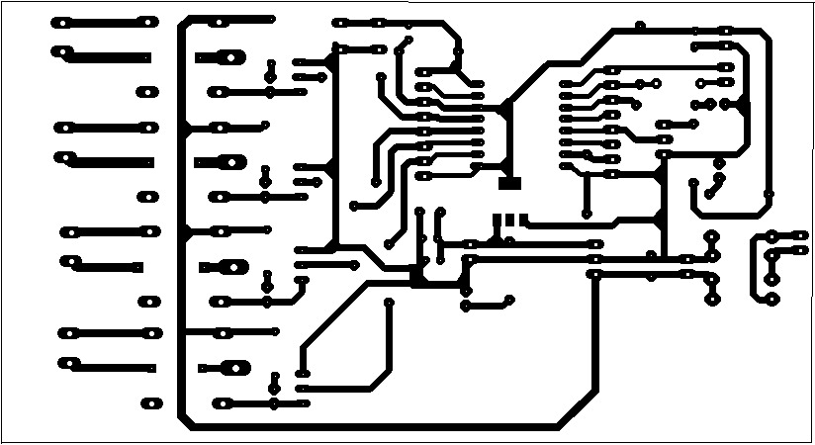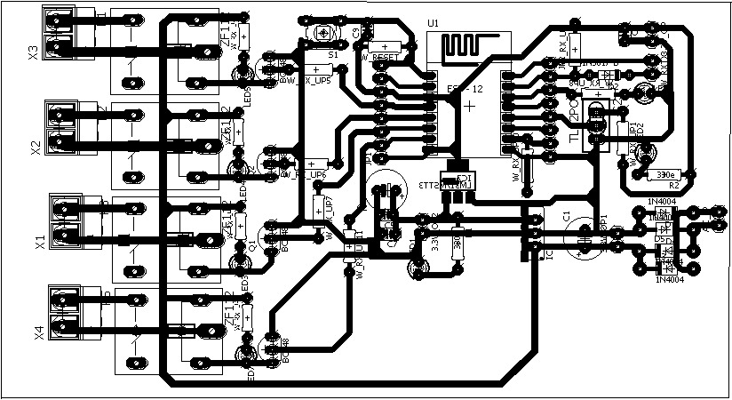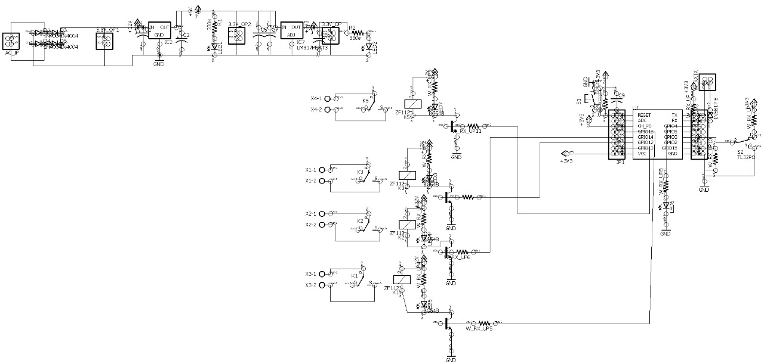

#### Discussion

It’s been a few years since we started hearing the buzz about a new type of domestic technology. Smart mirrors, robot vacuum cleaners, wireless kitchen appliances— interactive, internet-connected devices that would transform our lives. In 2019, IoT smart home device sales [will reach $13 billion](https://www.pwc.co.uk/industries/power-utilities/insights/energy2020/connected-home.html), and are [forecasted to reach a value](https://www.statista.com/topics/2430/smart-homes/) of more than $53 billion by 2022.

But in this always-connected IoT home of mood-sensing music systems, smart lighting, intelligent heating and cooling, motorized blinds, and automated windows and doors, there seems to be little discussion about why consumers haven’t unequivocally bought into the IoT home hype, or whether domestic life has actually improved as a result of it.

Considering how personal our homes are, shouldn’t it be a concern that the companies advertising these products tend to discuss “convenience, connectedness, and security” more than the potential improvement to the quality of life? Is the adoption of the Internet of Things (IoT) into our homes inevitable? Is it already here?

**Chapter 3**

### Conclusion

* This paper introduces a technology that will make human lives more versatile with increased security, ease, and to lead an upper class lifestyle inevitably creating our life's much simpler, finer, accessible and more steady. It represents innovativeness for operating a house replacing manual keys with digital codes and knocks for a door lock at home, thereby keeping in view of the growing Security trends in years to come and resolving the use hi-tech manual locks forour existing doors with a Digital Smart Lock. Moreover, thecost of execution of the developed system has been kept at low cost making it reasonable to all who seeks Security for home. As differentiated with most of the used technologies as narrated in the literature review, the Digital Smart home is convenient to execute and manage. It assists IoT, cellular technology and a non- proprietary open-source android system platform. The proposed standpoint registers to operate with Wi-Fi technology for integration, android based App for client ingress, and client testimonial for reliability and authentication, perceive the desired architecture. Hereafter, the sketched structure can be broadened to embrace other characteristics of home modernization and reliability. In addition, these experimentation assignments are often supplemented to reinforce other OS platforms distant from Android.

### Future scope

Internet of Things has emerged as a leading technology around the world. It has gained a lot of popularity in lesser time. Also, the advancements in Artificial Intelligence and Machine Learning have made the automation of IoT devices easy. Basically, AI and ML programs are combined with IoT devices to give them proper automation. Due to this, IoT has also expanded its area of application in various sectors. Here, in this section,

#### Extension of this work

IoT, taking in all "things" that can be sensed by sensors, without requiring them to be fitted with a tag or a digital network interface. These physical entities, whatever they may be (legacy appliances, passive items, subsets of physical space), become nodes of a broader network, extending the internet of sensor/actuator devices. We explain how such an evolution for environment-to-information interfaces draws upon a similar, long-standing evolution of human-to-information interfaces. Multisensor acquisition of physical context supports this extended IoT, bypassing the need for network-ready identification of target entities. We describe a three-layer reference architecture for an infrastructure supporting the integration of applications into the extended IoT

**Bibliography**

* N. Bhanja, S. K. Dhara, A. Das, T. Paul, S. Mukherjee, P. Roy Chowdhury, I. Kushary “A New Designing Approach of SAVI (Sensing Aided for Visually Impaired)” International Journal of Engineering Research & Technology (IJERT) ISSN: 2278-0181, Volume-11, Issue- 9.
* Shancang Li Theo TryfonasHongleiLi , (2016),"The Internet of Things: a security point of view", Internet Research, Vol. 26 Iss 2 pp. 337 - 359.
* Hindawi Publishing Corporation Mobile Information Systems Volume 2016, Article ID 8019830 Research Article Enhancing the Security of Personal Identification Numbers with Three-Dimensional Displays.
* International Conference on Electrical, Electronics, and Optimization Techniques (ICEEOT) - 2016 978-1- 4673- 9939-5/16/$31.00 ©2016 IEEE Overview of Fingerprint Recognition System Mouad .M.H.Ali, Vivek H. Mahale, PravinYannawar, A. T. Gaikwad.
* Ni Ni San Hlaing, San SanLwin, “Electronic Door Lock using RFID and Password Based on Arduino” International Journal of Trend in Scientific Research and Development (IJTSRD) Volume: 3 | Issue: 3 | Mar-Apr 2019 Available Online: [www.ijtsrd.com](http://www.ijtsrd.com/) e-ISSN: 2456 – 6470.

***Thank you***